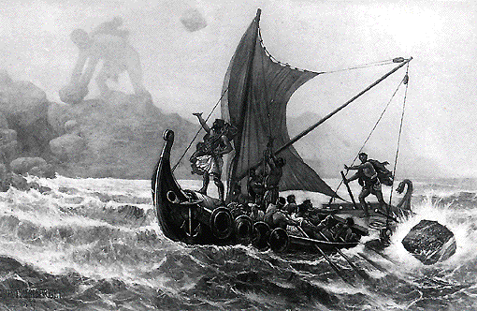
Odyssey Webquest

Created by Mr. Davidson (University of Detroit Jesuit High School and Academy)

Purpose: Building background knowledge is one of the keys to reading comprehension. When you have more knowledge to make connections to while you read, you are more likely to understand and remember that information you have read. This activity will help with this.

Directions: Go to the website odyssey-webquest.weebly.com to access all of the resources necessary for this activity. On your handout, please write all of the answers in complete sentences. You will need to explore several different websites to find all of the information. You do not need to copy down every last fact, but you should demonstrate a basic understanding of the material.

Part One: Who is Homer?
- Who was Homer?

- When and where was he born?

- What was Homer like?

- What two major works are attributed to Homer?

Part Two: Terms and Conventions
Define the following…
- Epic

- Epic hero
- Epithets

Part Three: Odyssey Online: Greece
For each section, answer the following questions…
- Epics and Actors: Where does the word theater come from? What did theaters look like at the time?

- Epics and Actors: Which god’s festival was the cause for developing dramatic performances?

- Geography: What three seas surround Greece?

- Geography: What is Troy?

- Geography: What is Ithaca?

- Victory and Conquest: Where does the word “athletics” come from?

- Victory and Conquest: What athletic events were included in ancient pentathlons?

- Victory and Conquest: What was the crowning prize for a winning athlete?

- Victory and Conquest: How old were soldiers trained in Athens? How old were soldiers trained in Sparta?

- American Cities/Greek Names: What are the four cities in Michigan whose names have Greek roots?

Part Four: Themes
- Create a list of topics from this website to keep in mind while you read…

Part Five: Encyclopedia Mythica
Define the following terms…
- Aeolus

- Athena

- Poseidon

- Zeus

- Laertes

- Odysseus

- Penelope

- Telemachus

- Tiresias

- Calypso

- Charybdis

- Circe

- Cyclops

- Muses

- Scylla

- Sirens

